**Insert School Logo**

**Semester Two Examination 2019**

**Question/Answer Booklet**

**MATHEMATICS**

**METHODS UNITS 1 & 2**

**Section One:**

**Calculator–free**

|  |
| --- |
| Student Name: _____________________________________ |
| Teacher’s Name: _____________________________________ |
|  |

**Time allowed for this section**

Reading time before commencing work: five minutes

Working time for paper: fifty minutes

**Material required/recommended for this section**

**To be provided by the supervisor**

This Question/Answer booklet

Formula Sheet

**To be provided by the candidate**

Standard items: pens (blue/black preferred), pencils (including coloured), sharpener, correction tape/fluid, erasers, ruler, highlighters

Special Items: nil

**Important note to candidates**

No other items may be taken into the examination room. It is **your** responsibility to ensure that you do not have any unauthorised notes or other items of a non–personal nature in the examination room. If you have any unauthorised material with you, hand it to the supervisor **before** reading any further.

**Structure of this paper**

|  |  |  |  |  |  |
| --- | --- | --- | --- | --- | --- |
|  | Number of questions available | Number of questions to be attempted | Working time (minutes) | Marks available | Percentage of exam |
| **Section One**  **Calculator—free** | **9** | **9** | **50** | **52** | **35** |
| Section Two  Calculator—assumed | 14 | 14 | 100 | 98 | 65 |
|  | | | |  | 100 |

**Instructions to candidates**

1. The rules for the conduct of Western Australian external examinations are detailed in the *Year 12 Information Handbook 2019.* Sitting this examination implies that you agree to abide by these rules.
2. Answer the questions according to the following instructions.

Section One: Write answers in this Question/Answer Booklet. Answer **all** questions.

**Show all your working clearly.** Your working should be in sufficient detail to allow your

answers to be checked readily and for marks to be awarded for reasoning. Incorrect

answers given without supporting reasoning cannot be allocated any marks. For any

question or part question worth more than two marks, valid working or justification is

required to receive full marks. If you repeat an answer to any question, ensure that you

cancel the answer you do not wish to have marked.

It is recommended that you **do not use pencil**, except in diagrams.

1. You must be careful to confine your responses to the specific questions asked and to follow any instructions that are specific to a particular question.
2. Spare pages are included at the end of this booklet. They can be used for planning your responses and/or as additional space if required to continue an answer.

* Planning: If you use the spare pages for planning, indicate this clearly at the top of the

page.

* Continuing an answer: If you need to use the space to continue an answer, indicate in the original answer space where the answer is continued, i.e. give the page number. Fill in the number of the question that you are continuing to answer at the top of the page.

1. The Formula Sheet is **not** handed in with your Question/Answer Booklet.

# Section One: Calculator–free 52 marks

This section has **nine (9)** questions. Attempt **all** questions. Write your answers in the spaces provided.

Spare pages are included at the end of this booklet. They can be used for planning your responses and/or as additional space if required to continue an answer.

* Planning: If you use the spare pages for planning, indicate this clearly at the top of the page.
* Continuing an answer: If you need to use the space to continue an answer, indicate in the original answer space where the answer is continued, i.e. give the page number. Fill in the number of the question(s) that you are continuing to answer at the top of the page.

Working time: 50 minutes

**Question 1 (5 marks)**

Simplify each of the following, giving your answers with positive indices.

(a) 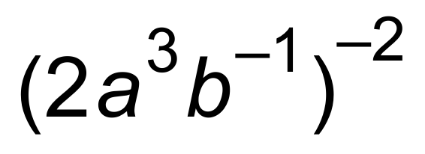 (2 marks)

(b) 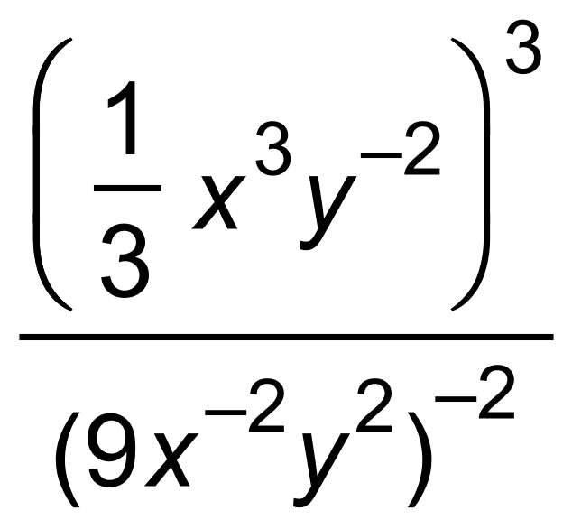 (3 marks)

**Question 2 (6 marks)**

Solve the following exponential equations, giving your answers as exact values.

(a) 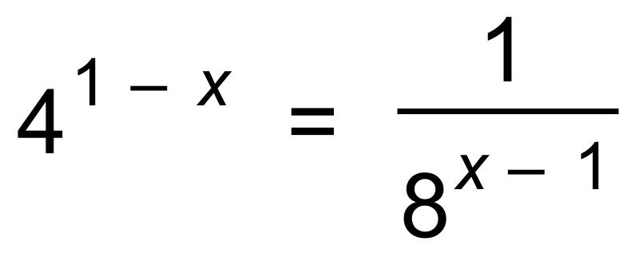 (2 marks)

(b) 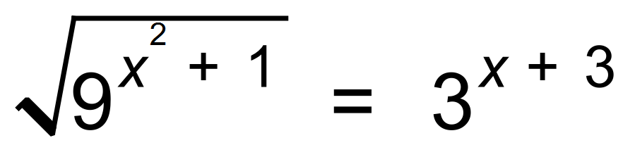 (4 marks)

**Question 3 (6 marks)**

Consider the graph of y = f (x), passing through (0, 4).

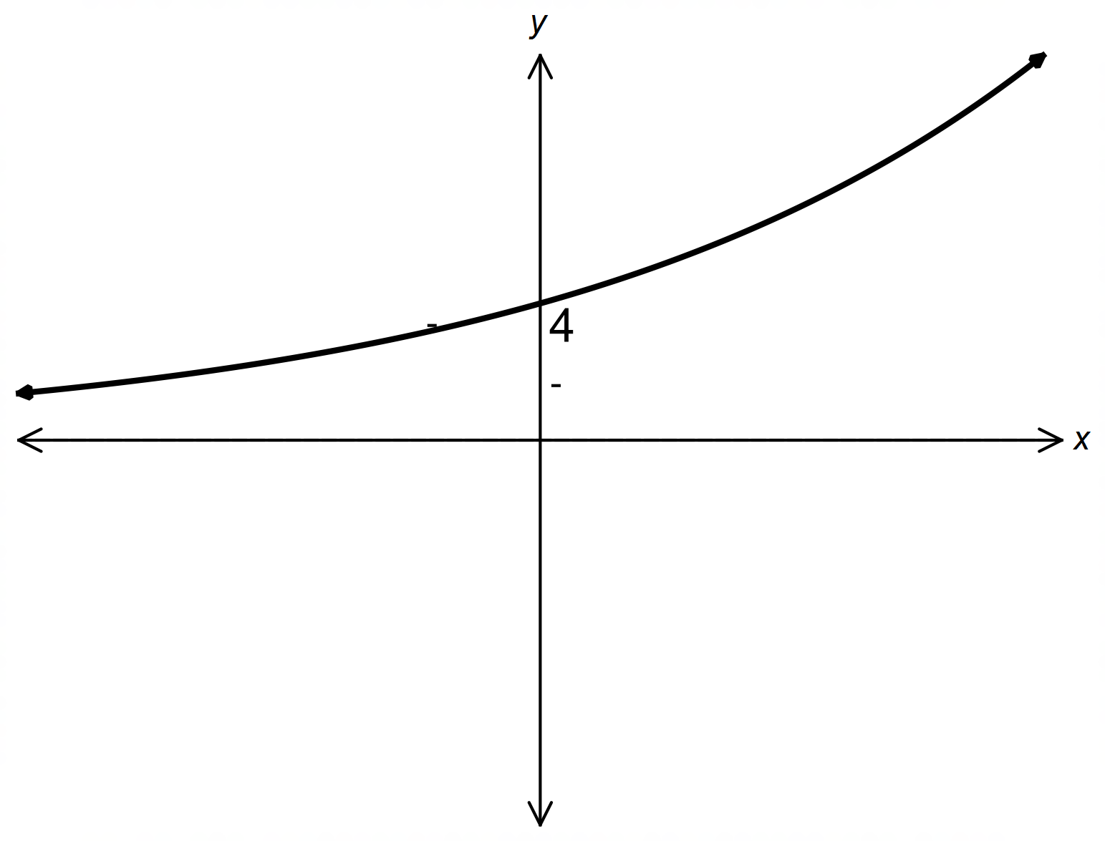

(a) If f (x) = max, determine:

(i) m. (1 mark)

(ii) f (−2), in terms of a. (Leave with positive indices.) (1 mark)

(b) On the same set of axes, and with clear labelling, sketch:

(i) y = f (−x). (2 marks)

(ii) y = f (x) − 6 (2 marks)

**Question 4 (5 marks)**

(a) Determine the derivative with respect to x of each of the following.

(i) 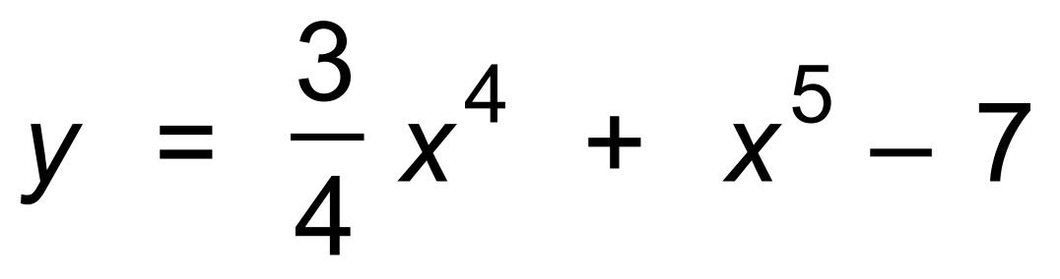 (2 marks)

(ii) 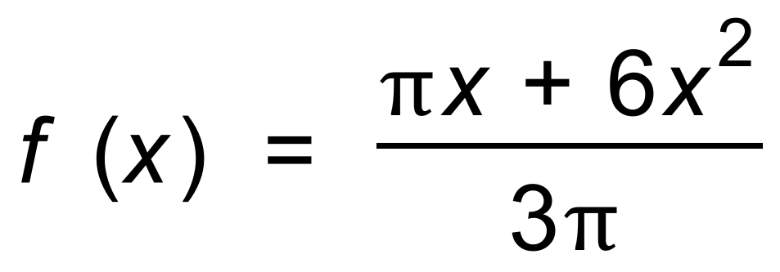 (2 marks)

(b) Simplify 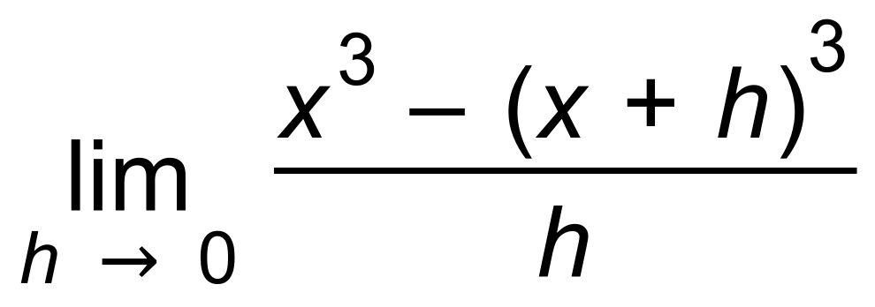 (1 mark)

**Question 5 (9 marks)**

Given 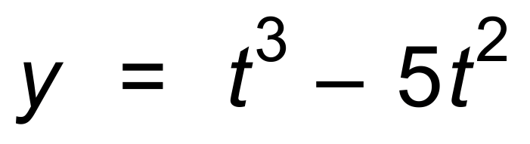, determine:

(a) (i) the average rate of change of the function between t = 1 and t = 3. (2 marks)

(ii) the instantaneous rate of change of the function at t = 2. (2 marks)

(b) Use the fact that 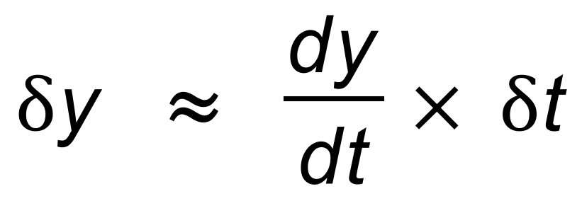 to determine the approximate change

in y as t increases from 1 to 3. (2 marks)

(c) Determine the equation of the tangent to the curve y = f (t) at the point where t = 2.

(3 marks)

**Question 6 (4 marks)**

Consider the displacement−time graph of a particle undergoing rectilinear motion shown below.

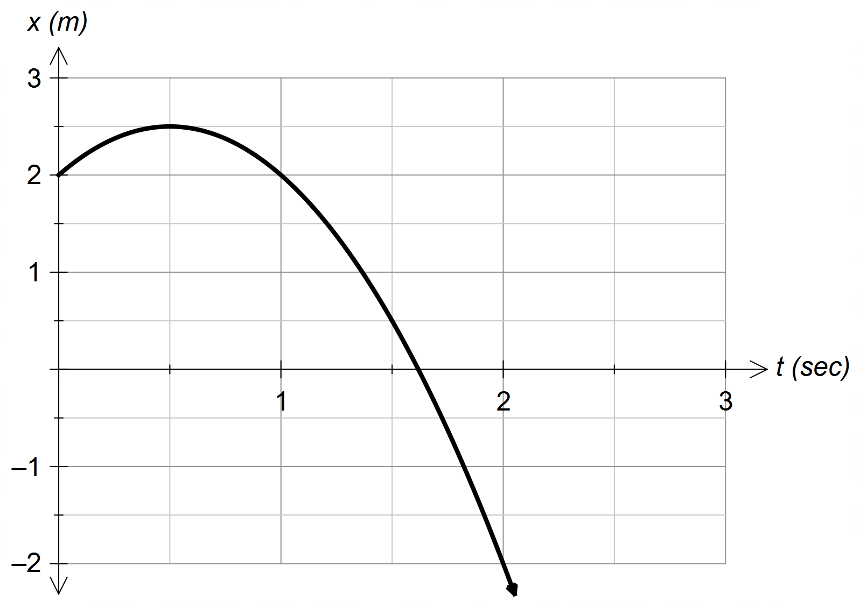

(a) Determine, correct to the nearest 0.5 sec:

(i) when the particle is at the origin. (1 mark)

(ii) when the particle is stationary. (1 mark)

(b) Determine the equation of the displacement, x(t), of the particle. (2 marks)

**Question 7 (5 marks)**

Determine the antiderivatives of the following.

(a) 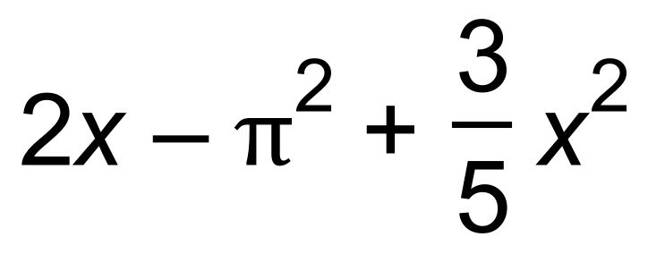 (2 marks)

(b) 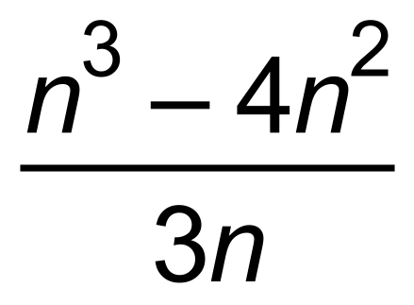 (3 marks)

**Question 8 (6 marks)**

James decides to ride from Perth to Sydney, a 3940 km journey.

He decides to leave on October 1st and travels 100 km the first day.

It happens that James manages to increase the number of kilometres travelled each

day by 10 km, so travels 110 km the second day and continues travelling in that sequence.

(a) Write the number of kilometres travelled by James each day as a recursive rule.

(1 mark)

(b) Write the number of kilometres travelled by James each day as a non−recursive rule,

in terms of n. (1 mark)

(c) How far will James travel on October 8th? Show your working. (2 marks)

(d) How far from Perth will James be at the end of October 12th?

Show your working. (2 marks)

**Question 9 (6 marks)**

Sketch a graph for each of the functions with the features shown over the domain 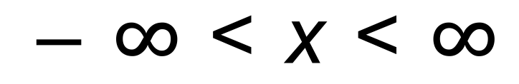. Label your graphs clearly.

(a) 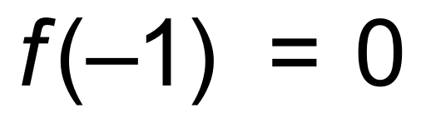 and *f* (0) = 1

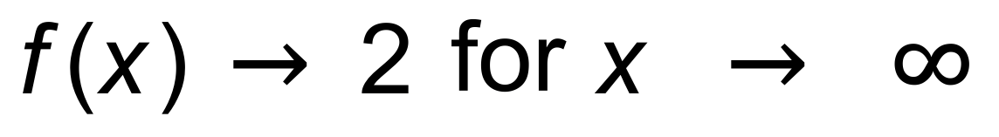

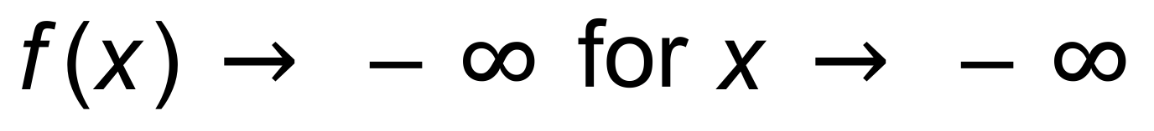 (3 marks)

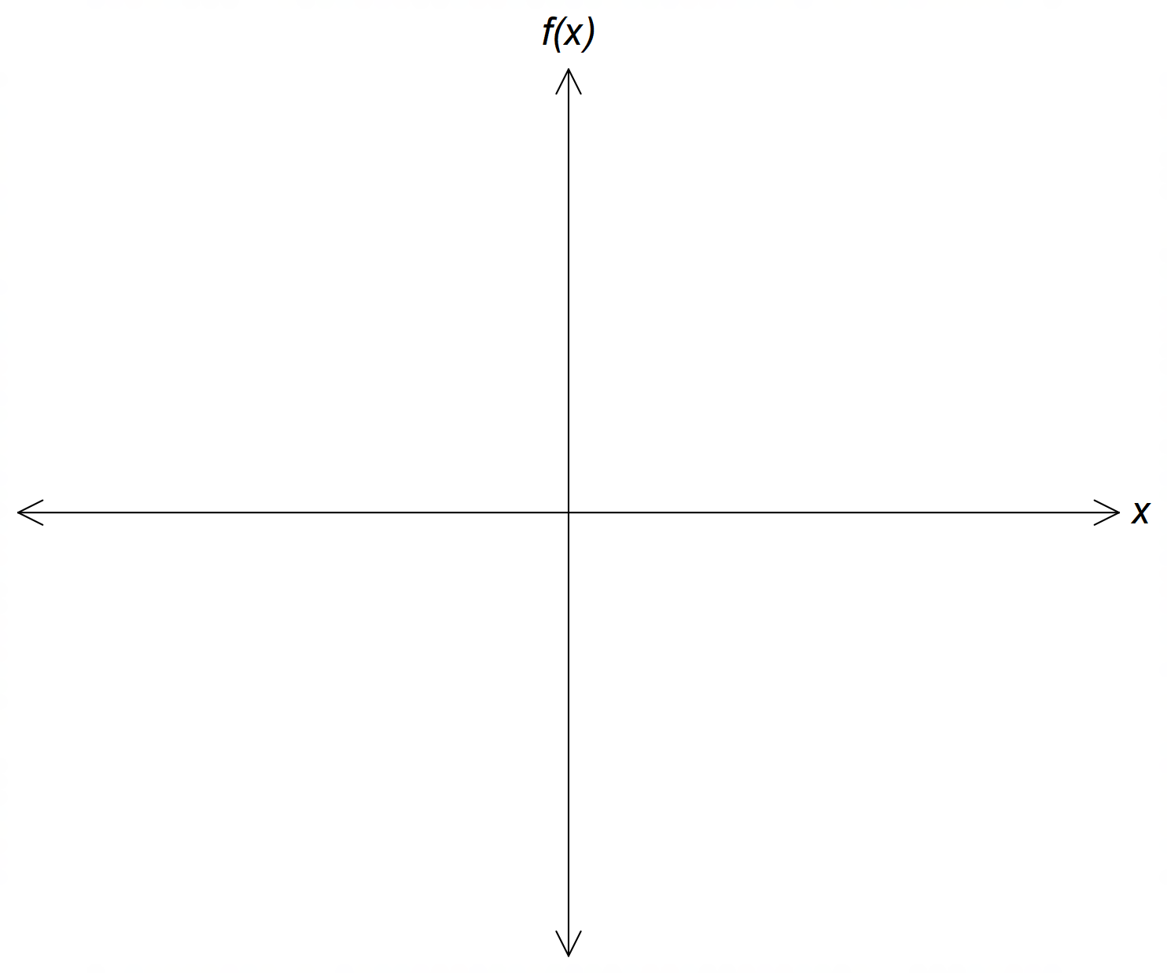

(b) *g*(*x*) has a stationary point at *x* = 2

*g*(*x*) has a global maximum at *x* = 2

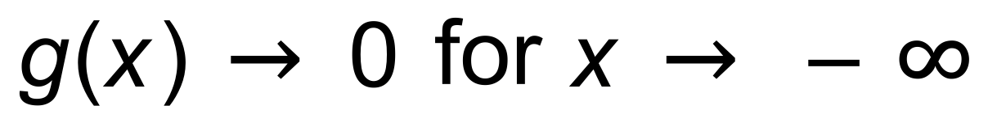

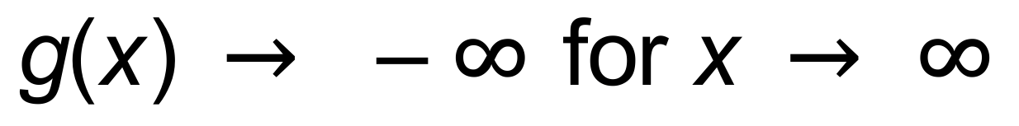 (3 marks)

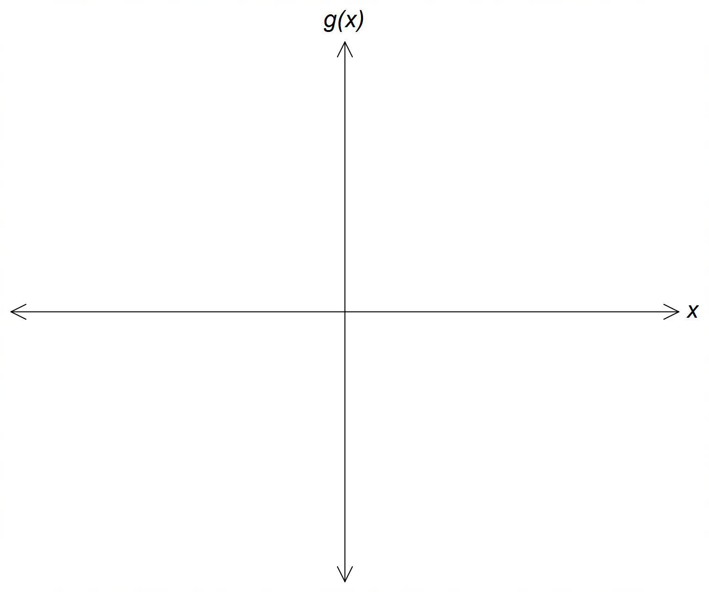

**End of Section One**

**Additional working space**

Question number(s): ……………………